# Organisation of an Innovation Dissertation

The following pages provide an example of how to organise your innovation dissertation. Each project is different so discuss with your supervisor the appropriate final content.

**Write in the third person, past tense.**

### 

### Word count

The completed dissertation length should be between 8,000 and 10,000 words.

There are some additional factors to take into account and the following general University Guideline on word count is useful:

University policy should be interpreted to allow a 10% over-run without penalty (e.g. 1000-word assignment is allowed 1100 words, 2000-word assignment is allowed 2200 words, and so on.)   Permissible word count **excludes** student’s name, title of module and assignment, references to sources, bibliography, graphs, tables, maps, diagrams, captions and appendices.  These lie outside the stated word limit.

Some material can appear in appendices, such as program test reports, for example. Clarify these details with your supervisor if you have any doubts

### Coping with non-printed material

If your work involves the use of specific files, put them on a USB stick.  This will form an appendix to the dissertation report.  Tutors will need permanent access to the environment your software runs in.

Put a label on the USB stick with your name and the year. Details of the files should be put on a README file. Put a plastic pocket into your report to hold the USB stick in the relevant place in the appendix.



“FULL TITLE OF DISSERTATION”

Your full name

2019-2020

Innovation Dissertation

Department of Computer Science, Electronics

and Electrical Engineering

# Disclaimer

This work is original and has not been previously submitted in support of any other course or qualification.

<*Type your name in full and sign below it, giving the date*.>

# Abstract

<*This follows the title page, on a single sheet of paper (can be single-spaced) and is a statement of the aims, method and results of your work i.e. is a summary of everything*.>

# Acknowledgements

<*It is courteous to express thanks for assistance given by your supervisor, external people, schools, etc*.>

# Contents Page

<*List Chapters with titles, and sub-sections if not too numerous.  Page numbers MUST be given.  Include a list of Appendices. The Table of Contents feature in Word makes this easy*>.

# List of Figures/Photographs

<*Photographs/tables/illustrations normally go in the body of your text.  If you want to use a figure or table, it must be labelled with a number and title.  Figure legends go below figures in the main text, and table legends go above tables. Remember to refer to the figure or table in the text*.>

# Chapter 1 Background and Motivation

**Here are some ideas on what to write about in this section:**

* Brief Background to the topic under review
* Aims and Objectives
* Project Management
* Personal involvement (this section can be written in the first person)
* Stages of Work

Organisation and planning are absolutely key to producing a successful written assignment of any length but especially a final year project or dissertation simply because of the amount of work and time it will take. Planning involves as much thinking about what needs to be done as ‘doing’ it. Jot down all the different activities or tasks you will undertake to complete the process, then organise them into a chronological action plan. Put deadline dates in for completion of each activity or task in a diary or planner. Work backwards starting with the submission date, then when you need to finish proofreading, then when you will finish editing and revising your first and other drafts, etc. Having deadlines rather than starting times and dates will focus your mind and you will feel more satisfied when you have achieved a target. When you have your schedule together, check it with your supervisor. Their experience both as researchers and as guiding students means they have a realistic idea of how long each phase will take. Remember that your project management will be a part of the assessment. I recommend that you include a Gantt chart in this section of your dissertation. State how this has been used. Talk about Time Management – did you complete the project on time? Project monitoring is also a significant part of project management. All project activities should be carefully monitored while the project is being accomplished.

# Chapter 2 Business Case

The Business Case will be highly dependent on your dissertation topic and you should consult your project supervisor when starting to write it. The following sections would be included in a typical Business Case:

### Reasons

### Describe the reasons for doing the project e.g. the business problems which you are trying to solve. It might also be useful to describe how the project helps to achieve corporate objectives or strategies.

### Business options

### Describe the different options which have been considered and recommend an option. One option must always be the ‘Do nothing’ option. This option does not result in a project. Other options might be ‘Do the minimum we can’, ‘Do something else’ etc. The difference between these options are the benefits that the investment will buy. You should try to provide enough information that the approvers of the business case will be able to judge which option gives the best value for money.

### Expected benefits

### Describe the benefits of the recommended option in measurable terms. They can be both qualitative and quantitative.

### Expected downsides

### Describe any downsides. These are actual consequences of the project which are negative. If possible, quantify the downsides and include them in an investment appraisal.

### Timescale

### Describe two timescales: the project timescale and the timescale over which the benefits will be realised.

### Costs

### Describe two costs: the project costs, and the ongoing operations and maintenance costs which will be incurred over the benefits realisation timescale. State which corporate budget(s) will fund both these costs.

### Investment appraisal

### Weigh up on the one hand the costs (both project costs and ongoing operational and maintenance costs) and the downsides versus the benefits. There are lots of techniques which can be used e.g. return on investment, net present value, cash-flow statement, internal rate of return and payback period. You should be trying to quantify the value of a project as an investment.

### Major risks

### Describe the main project risks, their likely impact should they occur, and any proposed responses

**Your supervisor will give you feedback on:**

* What has been left out or overdone?
* Are any extra sections needed?
* Is the format of quotations and references correct?
* Is the work well organised?

# Chapter 3 Design

Describe the design methodology that you have chosen to implement your system, with justification.

Where possible demonstrate support from further independent reading.

Document how the end user requirements have been taken into account.

# Chapter 4 Implementation

Demonstrate how a system has been implemented that follows the design from the previous chapter.

Use Figures as appropriate.

Include evidence of complexity or the advanced technical aspects of the project.

# Chapter 5 Testing and Evaluation

Summarise the results that you have obtained from user testing or a test document. Cite literature sources as appropriate.

If questionnaires have been used it is a good idea to include graphs that show the results. Statistical analysis should be used if appropriate.

Provide your interpretation of the results, possibly comparing them with other work identified in your literature review.

# Chapter 6 Conclusions

Discuss the strengths and weaknesses of your project.

Have the Aims and Objectives been met?

Reflect on the process that you have undertaken to complete the project.

Review your business case and suggest the further work needed to fully implement it.

# References

Working at final year degree level requires an academic approach. This means you need to be informed about the topic area of your project. In practice you must read, and acknowledge what experts have said about the topic, ideally presenting agreement and disagreement. Quote or paraphrase what an expert has said, then give a full reference to the expert’s publication.

### Common misconceptions:

1.       No one has written about my topic.

There will always be something written on your topic out there, if not directly then in a closely related area. For example, if you can’t find experts work on WAP technology in Infant schools, try Secondary schools instead.

2.       I can’t find any published work about my topic.

You may not be looking the right way. Start with a search engine on the Internet, use specialist search tools available via SharePoint, and finally ask your supervisor for help.

3.       I have used lots of works for background but I don’t need to quote from them.

Yes you do. You must quote or paraphrase from published sources to get a good mark. Look back at the work you have read and choose relevant passages.

4.       You can’t give a reference for a website.

Yes you can, see The A.P.A Referencing Style booklet and web area.

5.       Previous students’ projects don’t count.

Yes they do, summarising their work can form a good starting point, but remember to give a reference.

#### Referencing guidelines

Every piece of information you have gather from your research MUST be referenced correctly, this will ensure that you do not fall into the bracket of plagiarism. Contrastingly, a correctly formatted reference can show your assessor the depth of knowledge that you have gathered, in addition to the logical application of such sources.

#### Referencing Tips

Further information on referencing can be found in the latest addition of the full APA guide. Please follow the link below:

Link <https://portal.chester.ac.uk/lis/SiteAssets/FindingInformation/APA%20full%20guide%20August%202019.pdf>

Please also draw your attention to the frequently asked questions section at the back of this document, this section highlights common mistakes, whilst offering you with solutions to your referencing queries.

#### Examples

A paper based book

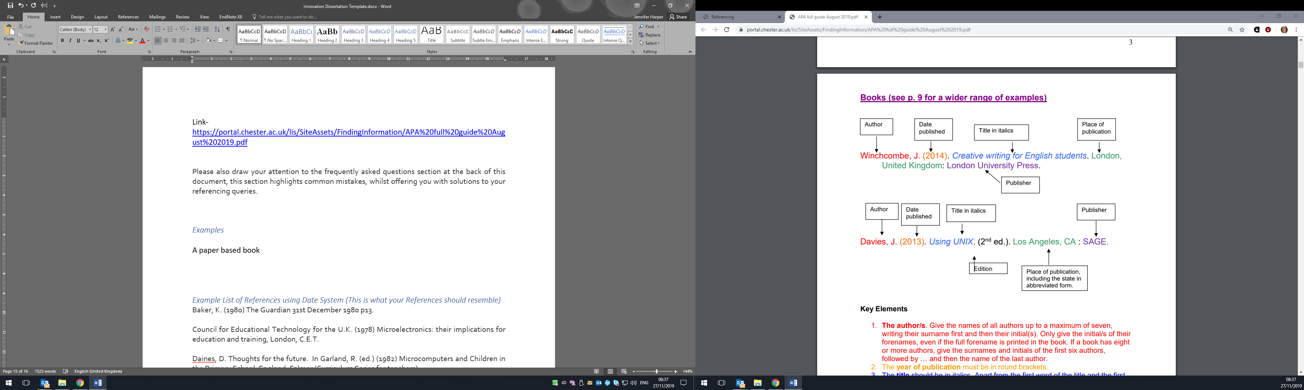

An online / E-book

Date published

Title in italics

Author

Darwin, C. (1859). *On the origin of the species by means of natural selection, or The preservation of favoured races in the struggle for life.* Retrieved from http:www/talkorigins.org/faqs/origin.html

Retrieval link

Paper based journals

Title of article

Title of journal

Date published

Author

Frost, S. S., Henderson, P., Andrews, A. S., Cooper, D. P., & Wilkinson, J. N. M. (1993). A review of recent research on the physiology of the bat. *Animal Research Quarterly, 33*(1), 92-115.

Issue number

Volume number

Page numbers

Electronic/ online journals

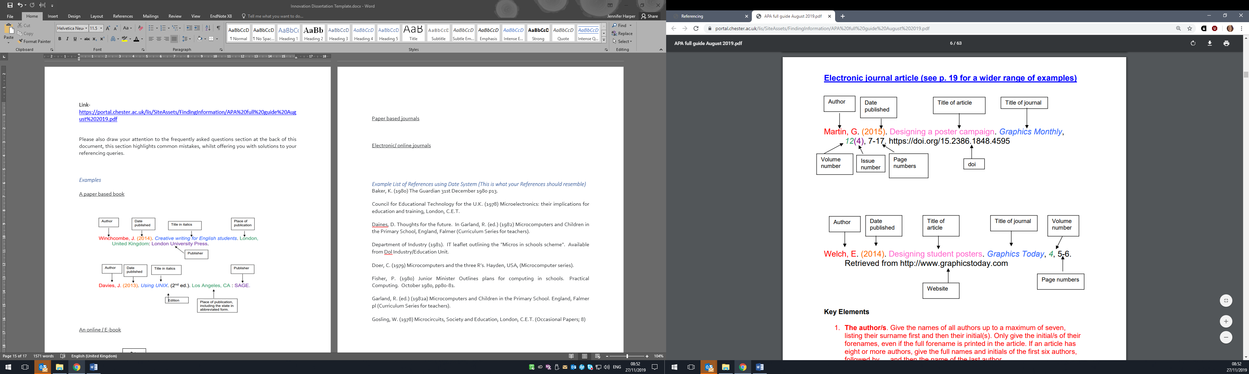

When referencing journals, notice that the italics format is in a different section in comparison to the structure of other references. When you use the APA guide to display your references, always make sure that you look closely at its individual sections in order to format it correctly.

When developing references from journal sources, you will be expected to structure the journals title and volume number in an italic format, please see above. Also notice that the issue number of the document is not formatted in an italic manner.

Websites

A document or page on a website

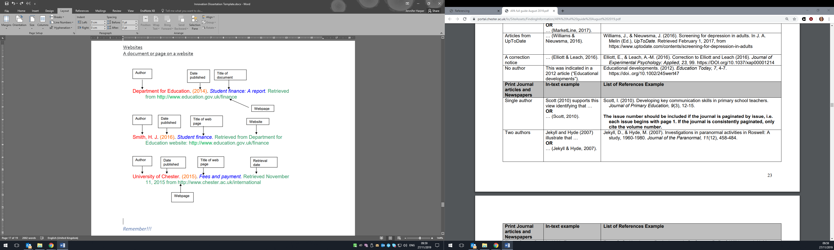

#### Remember!!!

Further source and referencing examples can be found in the full APA guide. Make sure you draw your attention to the differences when referencing multiple authors and how this can impact your in-text citation, in addition to your full referencing format.

#### FAQ on referencing

Follow the link for further information on the ‘frequently asked questions’ section that can be found in the full APA guide.

Link- <https://portal.chester.ac.uk/lis/SiteAssets/FindingInformation/APA%20full%20guide%20August%202019.pdf>

Q1. How do I include a citation in my writing?

Q2. What do I need to include in my reference list?

Q3. How do I format my reference list?

Q4. The text refers to another person’s work. How do I reference this?

Q5. How do I format quotations?

Q6. How do I cite and reference sources with the same author that are published in the same year?

Q7. How do I reference multiple sources that provide the same argument/idea?

Q8. I wish to reference my own work. How do I do this?

Q9. How do I format numbers in my writing?

Q10. How do I format abbreviations in in-text citations?

Q11. What do I do if I cannot find a date of publication?

Q12. How do I create a hanging indent in my reference list?

Q13. What is a DOI number?

Q14. How do I format the DOI number link for e-journal articles?

Q15. What do I do if there is no DOI number on an e-journal article?

Q16. How do I know the year of publication for pages/documents on websites?

#### Example of a reference list

Barnes, S., & Greller, L. M. (1994). Computer-mediated communication in the organization. *Communication Education, 43*(1), 129–142.

Carlson, J. R., & Zmud, R. W. (1999). Channel expansion theory and the experimental nature of media richness perceptions. *Academy of Management Journal, 4*2(2), 153–170. doi:10.2307/257090

D’Urso, S. C., & Rains, S. A. (2008). Examining the scope of channel expansion: A test of channel expansion theory with new and traditional communication media. *Management Communication Quarterly, 21*(1), 486–507.

Fulk, J., Flanagin, A. J., Kalman, M. E., Monge, P. R., & Ryan, T. (1996). Connective and communal public goods in interactive communication systems. *Communication Theory, 6*(1), 60–87. doi.org/10.1111/j.1468-2885.1996.tb00120.x

Korzenny, F. (1978). A theory of electronic propinquity: Mediated communication in organizations. *Communication Research, 5*(1), 3–23.

Rice, R. E. (1984). *The new media: Communication, research and technology*. Beverly Hills, CA: Sage.

Short, J., Williams, E., & Christie, B. (1976). *The social psychology of telecommunication*. London, United Kingdom: John Wiley.

World Economic Forum. (2019). *By 2030, this is what computers will be able to do*. Retrieved from https://www.weforum.org/agenda/2016/12/by-2030-this-is-what-computers-will-do/

#### Appendices

As a minimum, include a copy of your Ethics application.

Add other appendices as appropriate, e.g. a user guide.